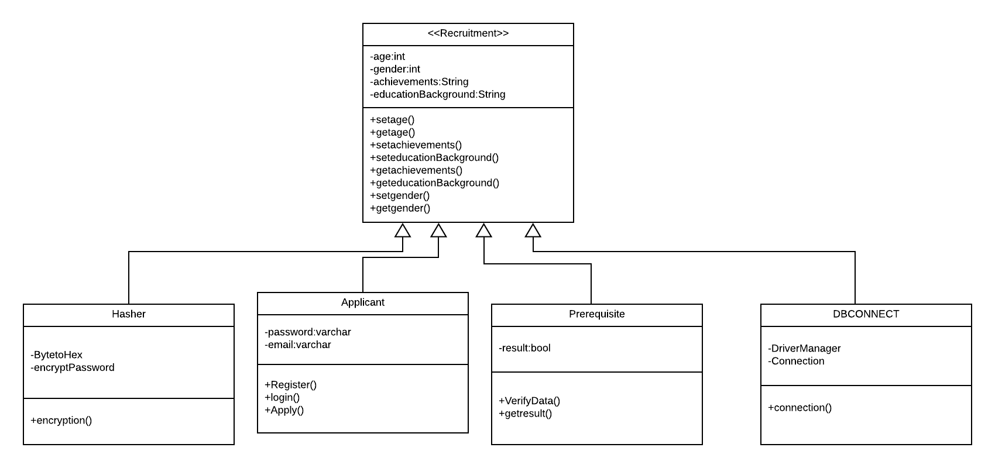

Figure 4.1 Class Diagram of the Job Recruitment System

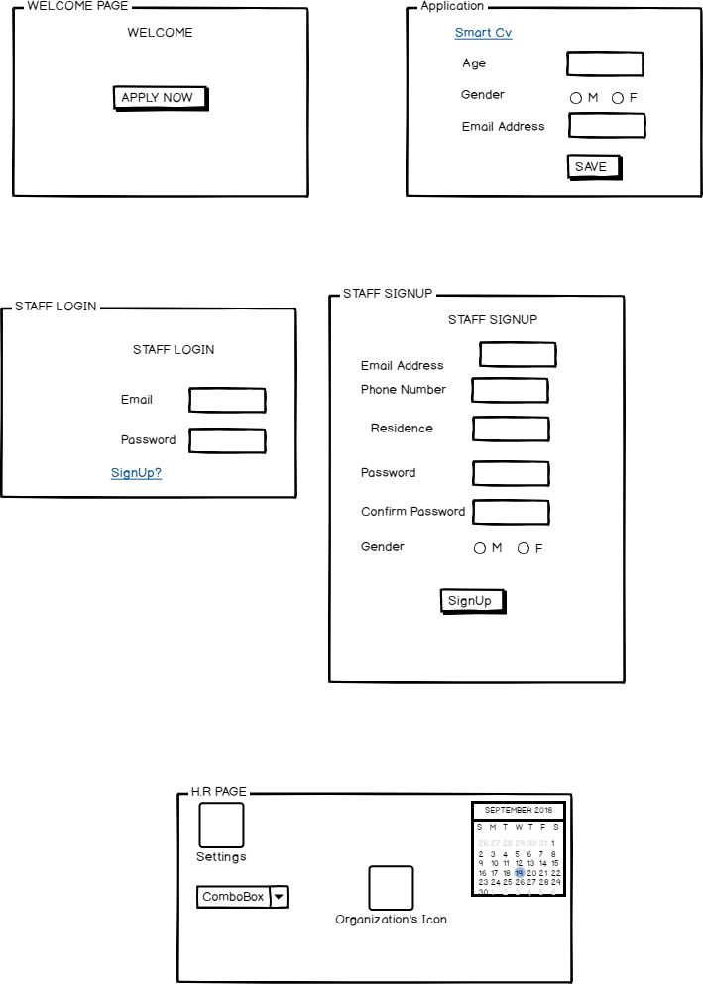

Figure 4.2 User Interface Diagrams

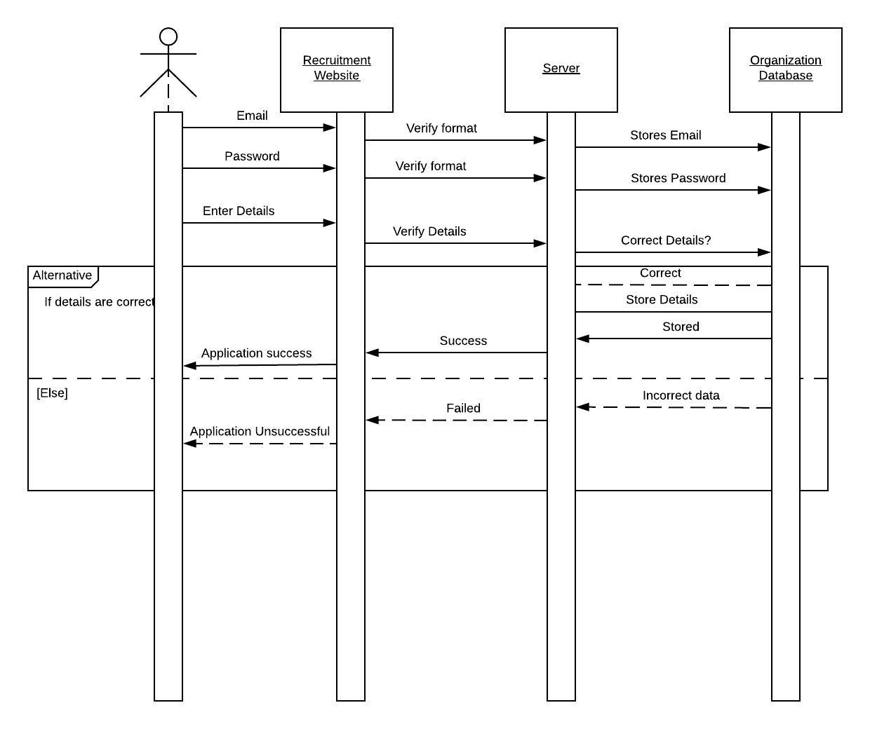

Figure 4.3 Sequence Diagram

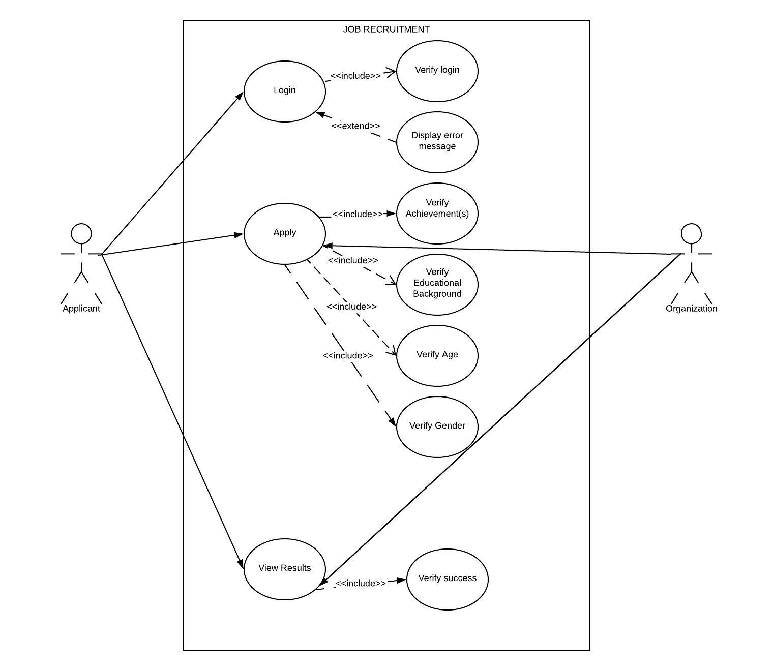

Figure 4.4 Use Case Diagram

FUNCTIONAL REQUIREMENTS

* The system should allow for user login as well as authentication.
* The system should accept applicant’s details and store them.
* The system should check if the applicant is qualified.

NON-FUNCTIONAL REQUIREMENTS

* The system is to be a web-based application
* The system is to generate periodical reports
* The system should be secure